Assignment 3 –

Assess the architecture of an AI-based system!

**Submission:**

1. What are key information that can be derived from the plot?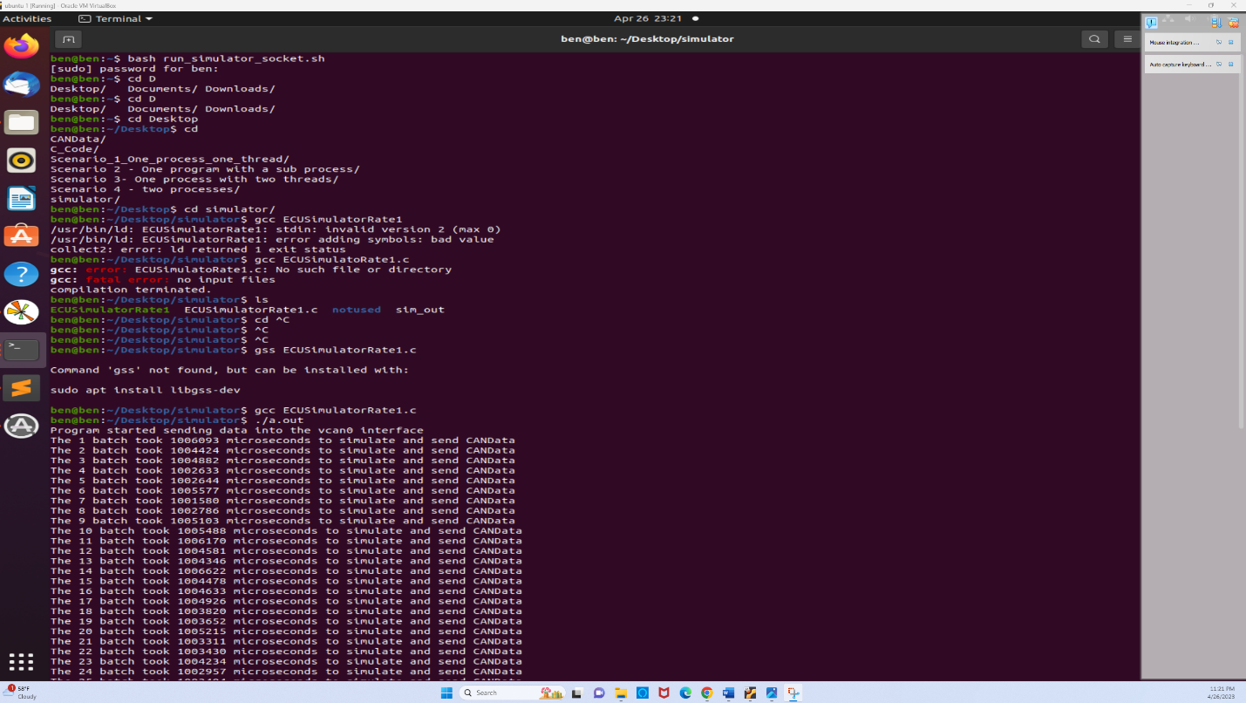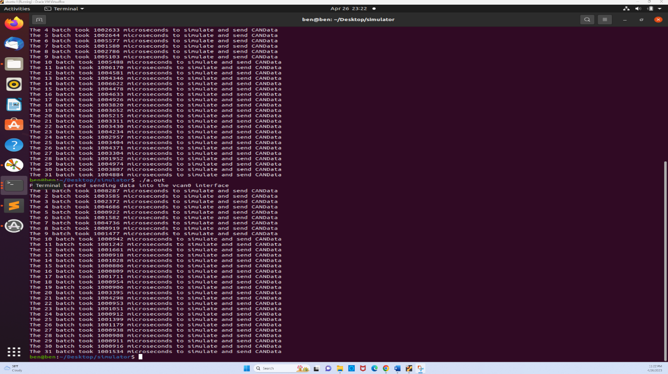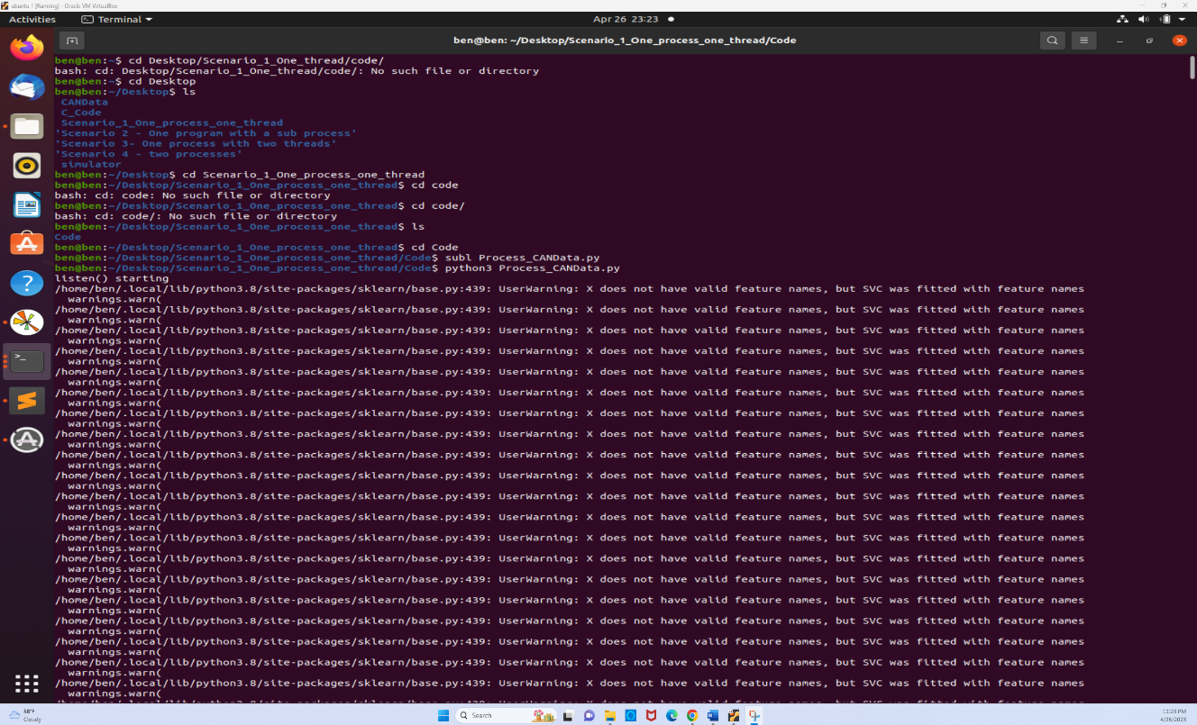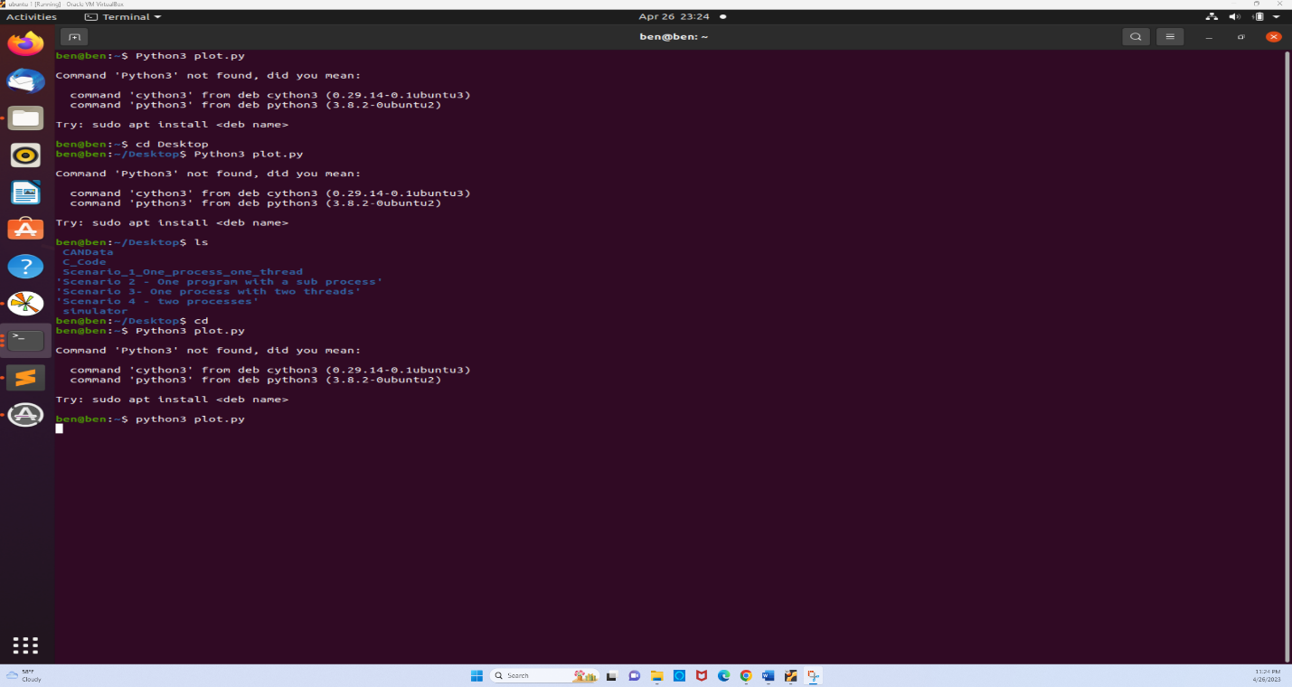

**OUTPUT**:

The plot is generated after the entire 6 steps  
This plot is about CANData Simulation vs Processing time. In which the processed data is represented to be in green which is of 6.45% of the data processed. The Y axis shows the Time(s) taken to process the data and the time is around 25 seconds. The X axis indicates the Batch Number in which the 93.55% is data loss which is huge. It indicates that there are lot of issues with the processing of the data which leads to inaccurate results from the machine learning model. It is represented in the red line.   
The Blue lines indicate the End of batch processing and CANData processing. The Green line indicates the CANData Simulation. Overall the plot provides insights into the performance and processing of the CANDAta. We can identify the issues and improve the performance.

**Section 2- Reflection**

1. Why do you think there is a data loss? Is it significant? Explain!

There are many reasons for the data loss during the simulation and processing of the CANData . The plot shows the significant data loss that means that the large portions of the CAN data packets are being dropped while processing causing backlog of the data packets. The processing time of the time differs widely between the batches which indicates that the processing time of the machine learning model is not perfect or inconsistent. Which leads to the data loss.

2. What could be possible solutions to mitigate data loss? You will receive Bonus points if you implement those solutions.  
There are the possible solutions to mitigate the data loss

* We can improve and optimize the machine learning model because the machine learning model used to process the data might not be efficient which takes longer time to complete. We need to optimize the model by implementing more effective algorithms and reduce the time complexity to reduce the data loss and increase the speed and accuracy.
* The other reason might be the protocol which is used to transfer the CANData packets between the ECUSimulator and python script might also impact the loss of the data. By using binary protocol we can improve the data transfer and reduce the data loss.